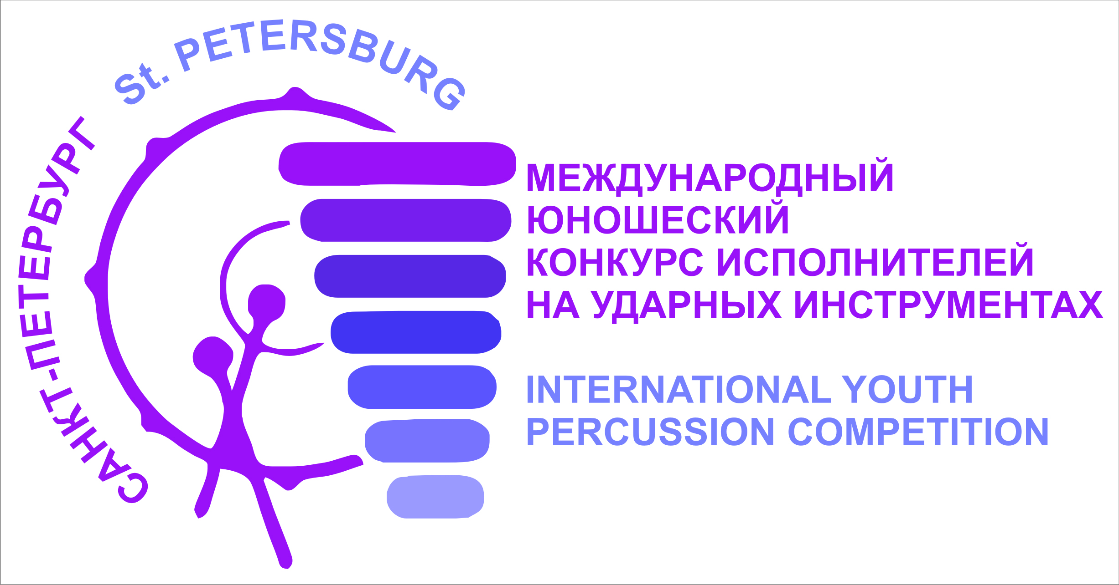

R U L E S

III International Youth Percussion Competition
St. Petersburg

St. Petersburg percussion society with the support of the Government of St. Petersburg organizes III International youth percussion competition. The Competition will be held online using video recordings From 7 to 12 December 2020.
Competitors of any nationality can participate. Competition is organized for students of Music schools, Colleges, Cultural and Art Educational Institutions.
The competition is divided into 6 nominations:

I nomination – Xylophone & Snare Drum (Orchestral Percussion)
II nomination – Vibraphone (solo)
III nomination – Marimba (solo)
IV nomination – Snare Drum (solo)
V nomination – Timpani
IV nomination – Percussion Duo*

And 5 age categories:
Cat. «Junior» (to 8 years old) (Only two rounds)
Cat. «А» (from 9 to 11 years old)
Cat. «B» (from 12 to 14 years old)
Cat. «C» (from 15 to 18 years old)
Cat. «D» (from 19 to 26 years old)
_____________________________
* In the nomination Percussion Duo the age category is defined by the average age of the participants

Each nominations has several age categories:
- The competitors nominations Vibraphone (solo), Marimba (solo), Snare Drum (solo) and Percussion Duo can participate only from age categories B, C, D.
- The competitors age categories “Junior” and «A» can take part only in the nomination " Xylophone & Snare Drum "
- The competitors nominations Timpani can participate only from age categories C, D.

- Each competitor can participate in no more than 3 nominations
- Age category is defined on 31 ^{th} of October 2020.

Competitive auditions will be held in 3 rounds:
R. I – Eliminatory Round – from 21th to 25th of November 2020 (a video recorded musical pieces must be sent)
For participants of the "Junior" age category, two rounds are organized.
R. II and R. III are held online using video recordings from 7 to 12th of December 2020.

The Organizing Committee reserves the right to decline applications for
admission which do not meet the requirement of the Competition.

For Round I (audition eliminatory round) the Selection Board will be composed of musicians and Teachers of international fame.

For every Section of instruments the Jury will be composed. It will consist of musicians and experts of international fame in the field of percussion.

The final results of the auditions (eliminatory round) will be announced by 25th of November on the following website: http://spbdrumpercussion.ru
Participants who have passed to the second round, send video files of the second round (youtube) and a receipt's payment of the entrance fee no later than December 7 by email: percussionspb@mail.ru
Participants who have passed to the third round, send video files of the third round (youtube) no later than December 10
The final results of the auditions (II and III round) will be announced on the following website: and http://spbdrumpercussion.ru

All decisions, at every stage of the Competition, will be final and sole.

The first – graded, the second – graded and third – graded competitors will be awarded with title “Laureate” and and prizes from sponsors

All the Competitors are required to send the application to the competition. The deadline is 21th of November 2020.

Please refer to the e-mail of the Competition: percussionspb@mail.ru
The form is enclosed.
All nominations require separate applications forms.

The application form must contain:
- a colour photo
- a birth certificate or a passport (a copy)
- a video file of the eliminatory round. (Only link on YouTube)

The programme of Eliminatory Round must obligatory include one or two freely chosen pieces up to maximum total duration of 10 min. according to the application for admission.

The Registration fee is 15 euro (regardless of the number of categories in which the participant takes part).
Registration fees are charged only from those participants who will enter the second round of the competition.
- Account for payment in foreign currency (EUR):
(ST) Vakula Nikolai Borisovich
ITN 470320689096
current account: 40802978103000000297
AO Raiffeisenbank
correspondent account: 30101810100000000723
BIC: 044030723
SWIFT: RZBMRUMM
purpose of payment: take participant International youth percussion competition St. Petersburg

Musical scores are available.

The official reference text is the one drawn up in the Russian Language..

Contact information:
Executive Director of the Competition –Boris Estrin bestrin@mail.ru , Tel. +7(921)315-43-42
Executive Secretary of the Competition – Elizaveta Romanova
eliza1606@yandex.ru , Tel.+7(921)927-01-06

